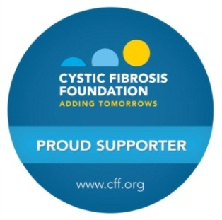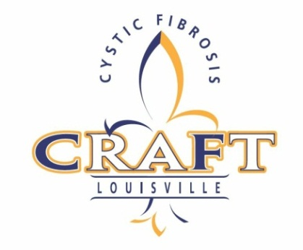

Volunteer Confirmation Form

Saturday, October 10, 2015

Volunteers will receive free entry into the event, free T-Shirt, pizza, water, and access to the volunteer area.

**A ticket must be purchased in order to sample alcohol and craft pizza during CRAFT.**

Please fill out the below information. Check the preferred times and jobs that you are interested in. Someone will be in touch once we receive the form. **This form is a commitment to volunteer.**

|  |  |  |
| --- | --- | --- |
| **Job** | **Description** | **Work Times**  (Please check the times you will work) |
| Set Up | Help set up and decorate the event space. | * 1:00pm – 6:00pm |
| Registration  (Involves Computers) | Help check people in when they arrive to the event. This includes selling tickets, distributing sample glasses and drink wristbands, etc. | * 6:00pm – 8:30pm |
| Food and Beverage | Provide samples at food and beverage stations. | * 6:00pm – 8:30pm * 8:30pm – 11:00pm |
| Misc. | Miscellaneous duties to include providing vendors with needs; trash collection; greeting guests, etc | * 6:00pm – 8:30pm * 8:30pm – 11:00pm |
| Check Out  (Involves Computers) | Collect payment at the end of the night, and work with auction volunteers to distribute auction items. | * 8:30pm – 11:00pm |
| Take Down | Help to tear down and clean up event space. | * 11:00pm – 12:30am |
| * I WILL WORK ALL NIGHT! 6pm – 11pm (Please mark above your job of preference) | | |

Name:_____________________________________________________________________

Address:_________________________________________Phone:______________________

City:______________________________State:________________Zip:_________________

Email:______________________________________________________________________

T-Shirt Size: **□ SMALL □ MEDIUM □ LARGE □ XL □ XXL**

Thank you for your time and commitment to help us find a cure for CF!

**Please return the form to:**

Sarah Foushee

10500 Fairmount Falls Way

Louisville, KY 40291

[CureCFInc@gmail.com](mailto:CureCFInc@gmail.com)

(502) 619-4059